ANNUAL ACTIVITIES
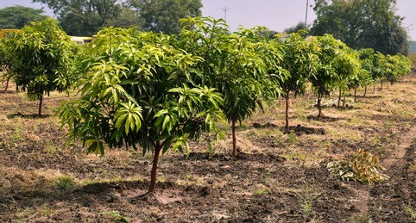
REPORT 2024-25

MEGHNA CHARITABLE TRUST
Registered Office:
N-4/208. IRC Village, Nayapalli, Bhubaneswar-751015
Odisha, India.
Phone: 0674-2556582,
Cell: 9437015501, 9937855487
Mail to: infomctindia@gmail.com
www.mctindia.org

MEGHNA CHARITABLE TRUST


ANNUAL REPORT-2024-25
REGISTERED OFFICE
N-4/208, IRC VILLAGE, NAYAPALLI, BHUBANESWAR-751015
ODHISHA, INDIA
PHONE NO-0674-2556582
CELL-9437015501,9937855487
Mail To: infomctindia@gmail.com
www.mctindia.org
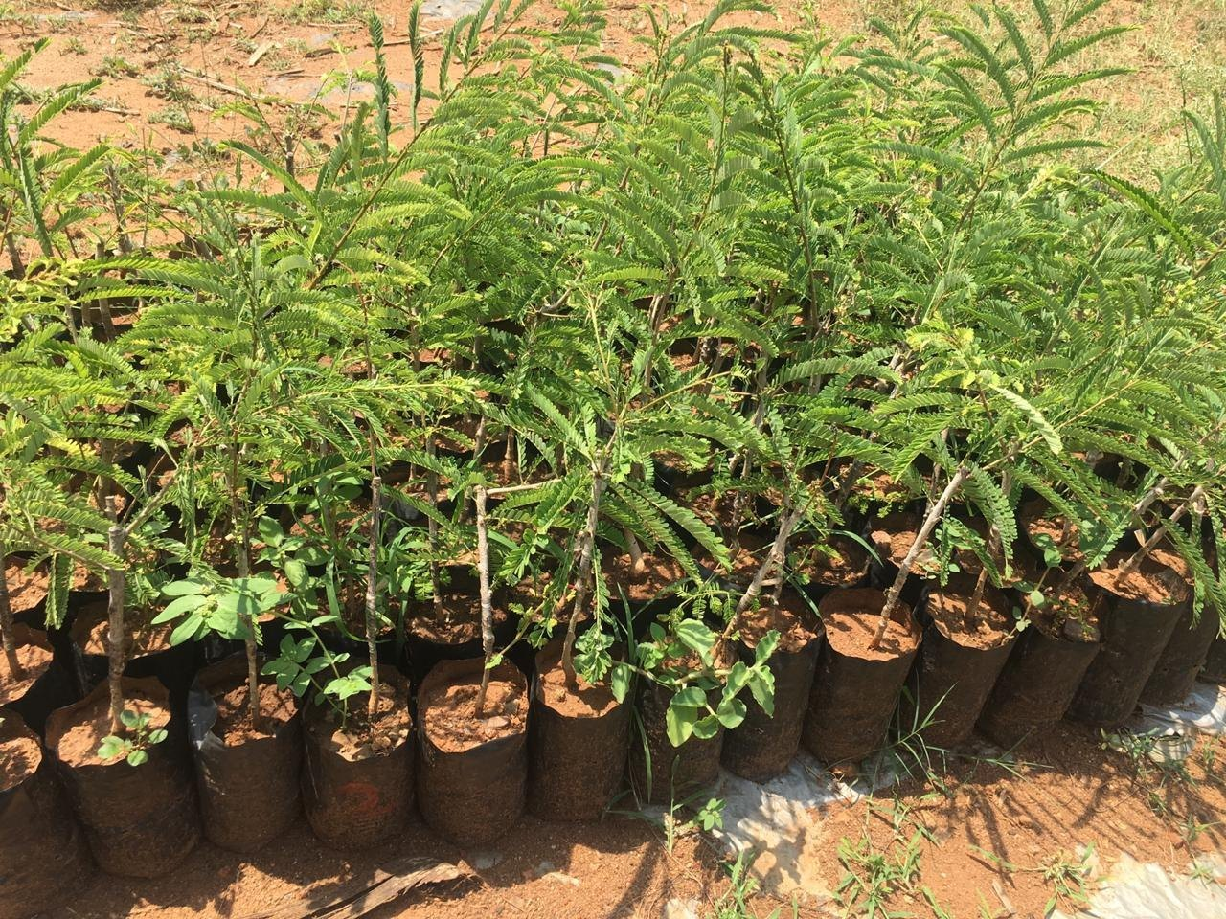

CORE VALUE

- TRANSPARENCY

- ACCOUNTABILITY

- INTEGRITY

- SOCIAL JUSTICE

- PARTICIPATORY APPROCH

MISSION

To empower poor people, develop their potential, improve their socio-economic status and eradicate poverty amongst them bringing sustainable development with emphasis on weaker and vulnerable section like SC, ST, Women, Children, Aged and the disadvantaged Poor

VISION

A society based on the values of equity, justice and liberty to all that will assure the wholesome development ensuring justice to right and responsibilities of citizens.

PREFACE

We take great pleasure in presenting the Annual Report 2024-25 of MEGHNA CHARITABLE TRUST (MCT) to our esteemed readers and supporters who have given us valuable insights and extended their cooperation in all our endeavors to fulfill the vision and mission and achieve the goals that we have strived together to accomplish. Squeezing of grants and donations by the donor agencies is a big challenge to fulfill the purpose that we think the development of society like innovative actions, empowerment initiatives for all sectors. Despite of all odds, MCT is striving hard to continue its effort to achieve the mission and vision.

As always, it gives us immense pleasure to share with our stakeholders a brief account of MCT programmers and activities implemented during the FY 24-25. We place in record our deep appreciation for the people's, organizations, CBOs, collaborating NGO partners, experts and the Government who reinforced their conviction and confidence in our interventions.

Finally, I wish together our organization for the development will bring cheer and happiness among the needy.

Mr Bikram Kumar Pradhan
Managing Trustee

GENESIS

MCT came into being in the year2004 as a support institution for infusing professionalism into the voluntary sector in the state. The approach was to provide an action forum and space to youth workers including volunteers towards community service and development, addressing the issues of poverty and wide spread illiteracy. The other approach was to groom the amateur youth social mobiliser as change agents, while rebuilding community institution through community leadership development organizing women. Spreading literacy, gradually the approach included the school. It is dedicated towards Human Recourses development and socio-economic empowerment of the society in district of Dhenkanal, Khurdha, Angul, Kendrapada, Keonjhar And Rayagada in the state of Odisha. Apart from managing the educational Institution of Global quality.

The venture has now turned out to be platform for a development-based venture that covers now major part of Odisha, and has geared up its momentum to cater to the macro aspect of development need people- mainly that socio-economically backward people who are suffering from social execution.

LEGAL STATUS:
- Registered under Indian Trust Act, 1882, dated 08.06.2004,
- Permanent Account Number AABTM2226K,
- Registered u/s. 12aa and 80G of the income Tax Act, 1961.
- Registered under FCRA 2010.
GEOGRAPHICAL AREA OF OPERATION:
Presently MEGHNA CHARTITABLE TRUST in short MCT, is working in the districts of Dhenkanal, Khurda, Angul, Kendrapada, Keonjhar & Rayagada in the state of Odisha and plans to expand its operations to other part of the Country.
IMPORTANCE OF MEDICINAL PLANT:
In the scenario where the entire would is scrambling to discover a cure for the covid-19 pandemic, many health experts have advised boosting the body's immune system which can help to minimize the effect and hasten the recovery from the disease. In this terrible situation medicinal herbs have emerged as a savior.
The doctor recommended to people to drink kadha (Formulation) made of Tulası leaves, Dry Ginger Powder, Black pepper, Dalchini, for increasing immunity system the uses of this medicinal plants is found in numerous india societies and is archived indian system of medication for the example Ayurveda, Siddha, Unanı, Swa-rigpa and Homeopathy.
Cultivation of medicinal herbs like Sankhapuspi, Atis, Kuph, Karanja, Guggl, Aloevera, Ashoka, Giloy, Musli, Satabari, Bramhi Aswagandha etc.
- Farmer Skill development trainings on sunflower, maize, vegetable, SRI and paddy cultivation.
- Bio-technology promotion for productivity enhancement of agriculture.
- Promotion of appropriate crop pattern.
- Quality seed production and seed preservation.
- Formation of farmers associations.
- Awareness on health rights and entitlements.

The medicinal plants find application in pharmaceutical, cosmetic, agricultural and food industry. The use of medicinal herbs for curing disease has been documented in history of all civilizations. Man, in the pre-historic era was probably not aware about the health hazards. Associated with irrational therapy with the unset of research in medicine it was concluded that plants contain active principles. Which are responsible for curative action of the herbs.

THRUST AREAS OF DEVELOPMENT:
➤ To uplift, and promote, the social, economic status, of tribal and schedule caste, occupationally poor and underprivileged.
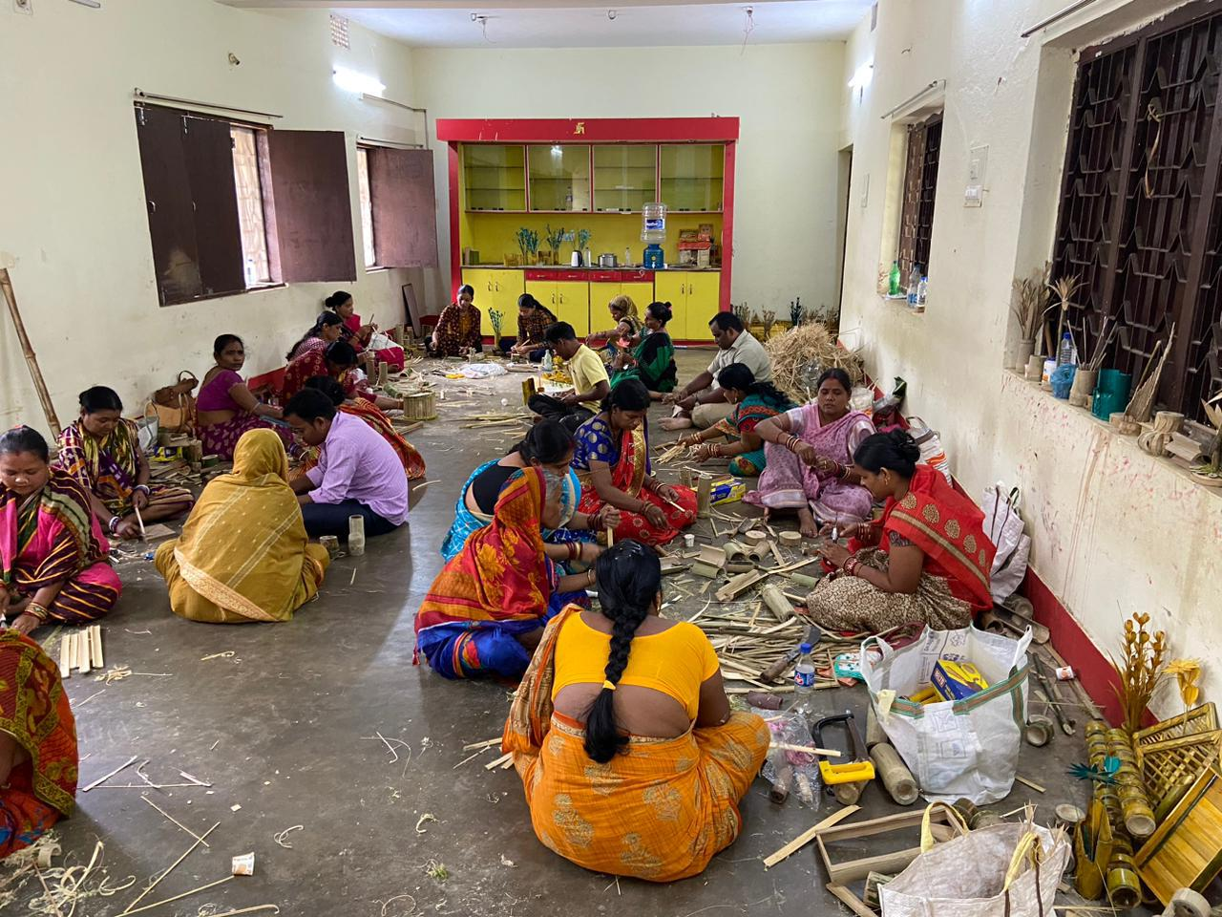
➤ To promote the Swachh Bharat Mission by educating of different segments of people about importance of swachhata through counseling and adopting different other suitable methods for utilizing it in practical fields.

➤ To promote women empowerment, facilitating education, opportunities and exemplifying best examples.
➤ To provide all sorts of help to poor for eradication of poverty.
➤To provide all special care to the SC, ST and backward people for enrooting them in proper path.
➤ To provide shelter, nutritious food, sanitation, proper health, exercise, yoga, requisite medical facilities for needy, infants & old age people.
➤ To promote the mission of new India by promoting the concept of skill India through Human resources development and skill building.
➤ To educate pupils, selecting from have- not groups earmarked for imparting education by erecting Educational institutions with State of Art facilities in different places of India.
To impart vocational training, to the needy students, on BPL criteria, by opening different vocational training institution.
➤ To facilitate employment solutions of the country industrial placement is encouraged/emphasized through global linking.
➤ In the present scenario, Health and Sanitation are the principal problem to fight with, for restoration of proper health. Hospitals to be Opened/constructed in different places from time and again medical camps are conducted for developing health awareness and sanitation etc.
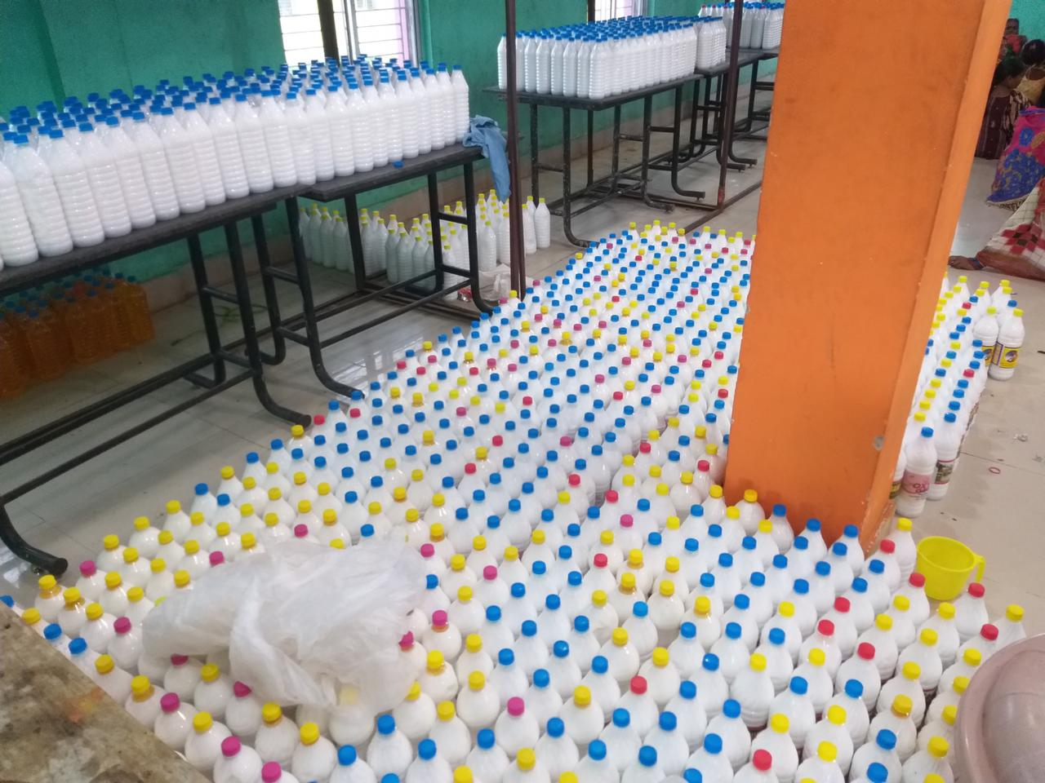
➤ To make people aware of the view to keep their body, mind and trust healthy by following National rules and regulations and of the Ancient Vedic Formulates and applying them practically in day-to-day life under guideline and direct supervision of Vedic Experts.

Management and Coordination:
The management system of MCT is well structured with organizational sub-systems that functions as the support and hand holding with the Educational institutions, various Line Departments of Govt. and Private Agencies. The support system has adopted the flexibility to suit the situation of the people in the context of occupation, fieldwork and leadership protocol of the communities.
Impacts & Effectiveness:
The interventions of MCT has resulted in socio-economic impacts with increase of employable job opportunities for the poor and marginalized youths and on the other side bringing back the up gradation of skills to youth's results in mobilizing resources for the development of infrastructure and increasing economic status of poor by obtaining maximum benefits of local market. The empowerment activities are more visible and accepted both by the community and job environment.
The interventions of MCT are found to be erective in mainly two ways. The first and foremost is to enable the unemployed youth to adopt a means of better livelihood in order to lead a dignified life, decision making process and equal representation. The second one is to improve the socio-economic status of youth through employment-linked skill-based training for the female folk living in socio economic difficult circumstances.
HUMAN RESOURCES DEVELOPMENT
Predominance of informal employment has become one of the central features of the labor market scenario in India. While the informal sector contributes around half of the GDP of the country, its dominance in the employment front is such that more than 90 percent of the total workforce has been engaged in the informal economy. Under the changer circumstances where informal sector is increasingly interlinked with the formal, and plays pervasive role in the economy and in the livelihoods of the people, it is imperative to improve the information base of the sector. It is necessary to build a comprehensive statistical base on various dimensions of the informal economy as an integral part of the national statistical system.
In Indian context the process of empowerment of the poor and marginalized of the society in making it possible that everyone get the benefit of the CONSTITUTIONAL PROVISIONS and have the "RIGHT TO ENTITLEMENTS", has made the MISSION of MCT successful of Reaching the un-reached, skilling the un-skilled, employment to the jobless, meeting the un-met need of the global market and importantly intending to make Technical Education a reality for those who can't afford.
QUALITY ISSUES
Design comprehensive phases for the motivations, interests of key stakeholders and the existing training culture. This helps to define what can realistically be achieved at the policy level, and ensure better sustainability prospects for the policy and education system dimensions of MCT programs Few standard indicators as well as principles for monitoring and results measurement has been adopted at MCT for the standardization.

NETWORKING AND KNOWLEDGE MANAGEMENT:
We have learnt the lessons for improving knowledge management covering aspects like role of focal points, thematic quality assurance, standard setting. thematic human resources etc., many of which are already addressed in the past, competencies and responsibilities in thematic quality assurarnice". approved by Management.
HEALTH INITIVES
SPECIAL CAMP ON MOTHER AND CHILD HEALTH:

Odisha with a population over 43 million have high levels of poverty, and poor maternal and child health concentrated among Scheduled Tribe and Scheduled Caste Communities. It identifies innovative and expanded provision of health services, reforms to the management and development of human resources for health, and the introduction of number of schemes as contributing to closing the gap between maternal and child health and nutrition outcome. The institutional delivery rate for Scheduled Tribes has risen from 11.7% in 2005-06 to 67.3% in 2011 and from 35.6% to 79.8% for all women. The social gradient has also closed for antenatal and postnatal care and immunization. Nutrition indicators though improving are proving slower MGD.
FARMERS EMPOWERMENT
TRAINING OF FARMERS ON TRADITIONAL AGRICULTURE
Traditional agriculture based on treating the soil and plants with products that are more likely than non-toxic, and more likely than not synthetically produced in a laboratory. These products are used to prevent disease or pests from blighting the plant.
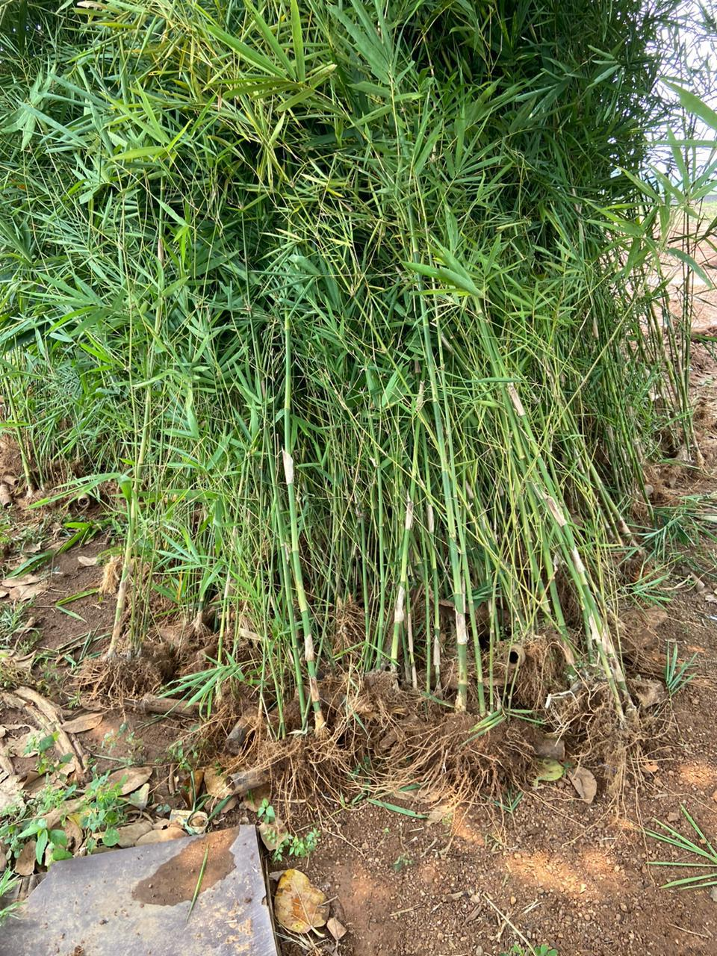
Selected farmers and agriculture practitioners were trained under the leadership of MEGHNA CHARITABLE TRUST to develop their leadership skills so that they, in turn, could lead their own rural communities toward sustainability. The training, designed and hosted by Agricultural experts. supported the farmers to engage in a series of technical trainings on climate change resilience, including topics such as: sustainable agricultural practices, renewable energy and bio-fuel, vegetable wicking beds for drought farming, community radio, and vegetable processing. Each trainee received a seed grant to train other in her community as well as launch her own livelihood practice.
WOMENS EMPOWERMENT
FORMATION AND STRENGTHENING OF WSHGS:
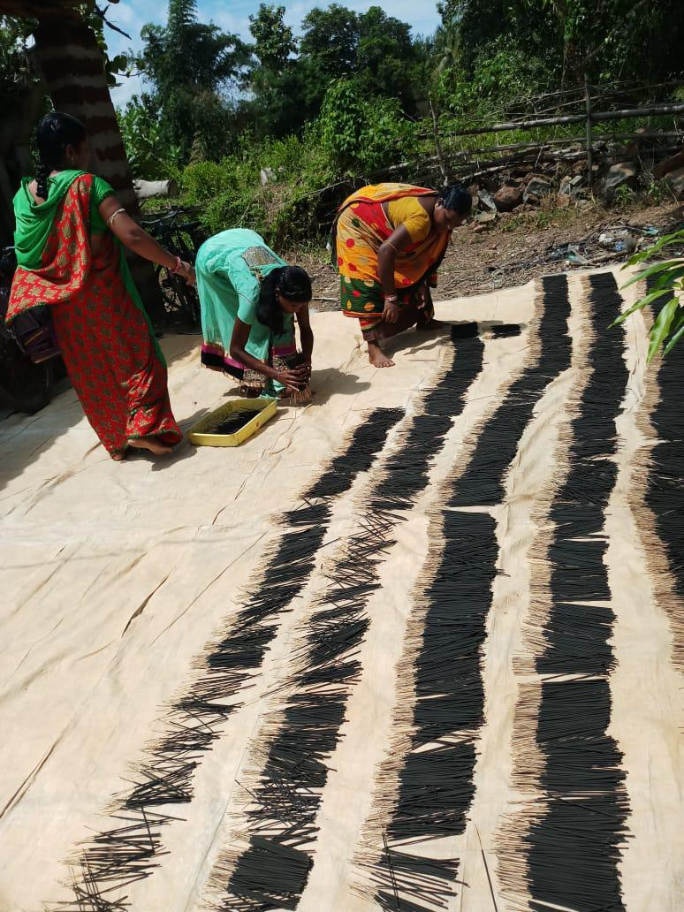
WOMEN'S ORGANICATION:
Generally, the men hold economic anchor in the family and
In the society. However, generally the income of the women
In the family is a sure insurance for the economic stability of the family. Hence women in formal group has been undertaken
To improve the income of women in the family there by ensure
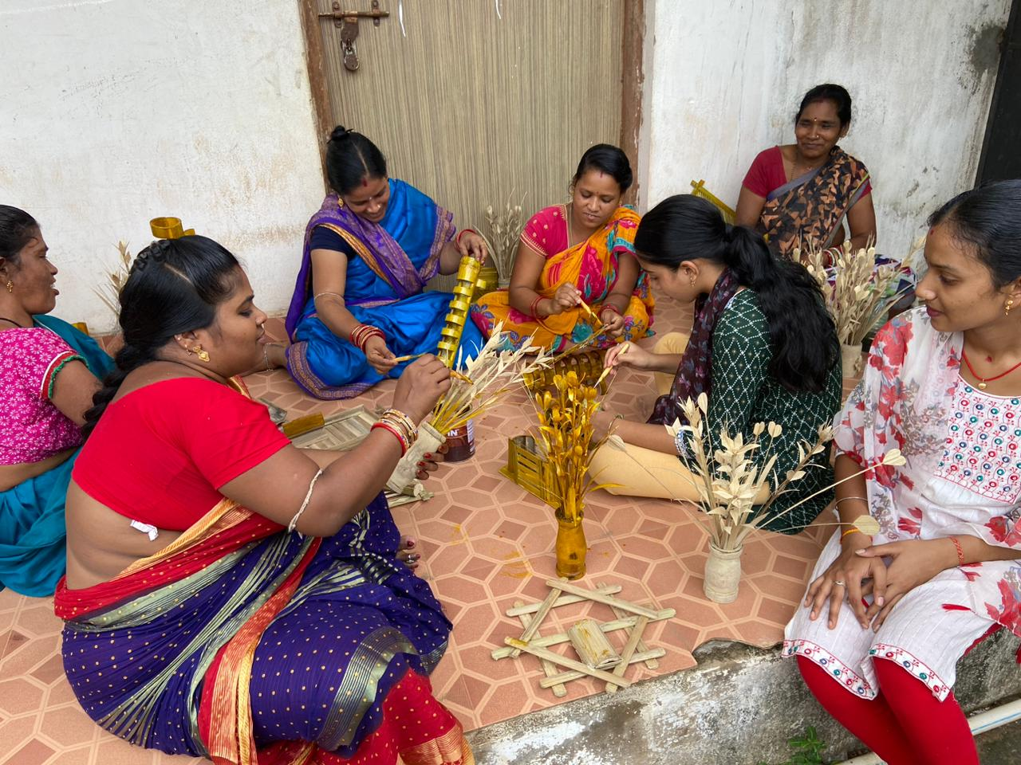
Economic development of the family.

- CAPACITY BUILDING TO DEVELOP WOMEN ORGANICATIONS
- DISPOSITION FUND
- SHG TRAINING PROGRAMMES & WORKSHOPS
- FOOD PROCESSING

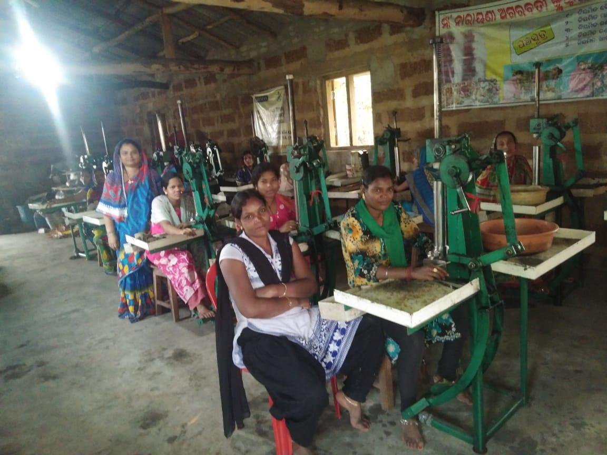

UNIVERSAL INITIATIVES
EDUCATION PROGRAMME FOR OUT OF SCHOOL CHILDRENS:
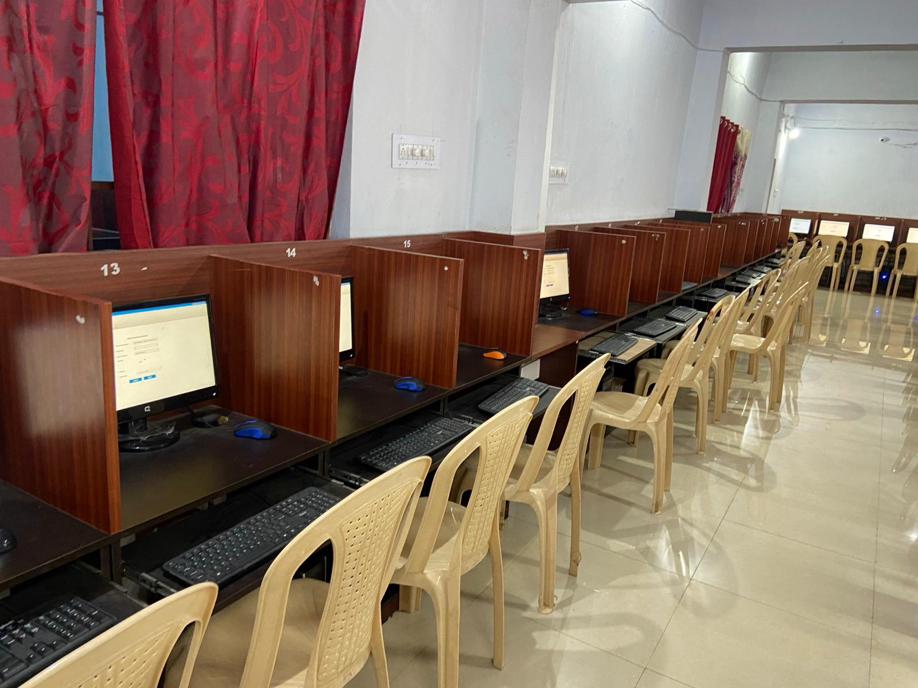
The goal of the Strengthening Education System for Out of School Children is to enhance institutional capacity of education systems to provide learning opportunities. Strategies are targeted towards creating a supportive atmosphere for the schooling of Children through a sustainable system and consistent program delivery.

During the year we have an estimated 2000 out of school Children had opportunities to participate in flexible learning programs that are equivalent to formal education. Many of these children are children in poverty, children with disabilities, migrant children, stateless children, girls, children in remote areas, and children of ethnic minorities. The knowledge and experience accumulated as a result of the project will be disseminated through portal sites, events, media, and publications. Further, the program was to enable government and partners to sustain and expand programs for Out of School Children through advocacy and capacity development. Through this process we have reached to 236 out of school children and were admitted them in different residential schools of Dhenkanal district.
INDEPENDENCE DAY:
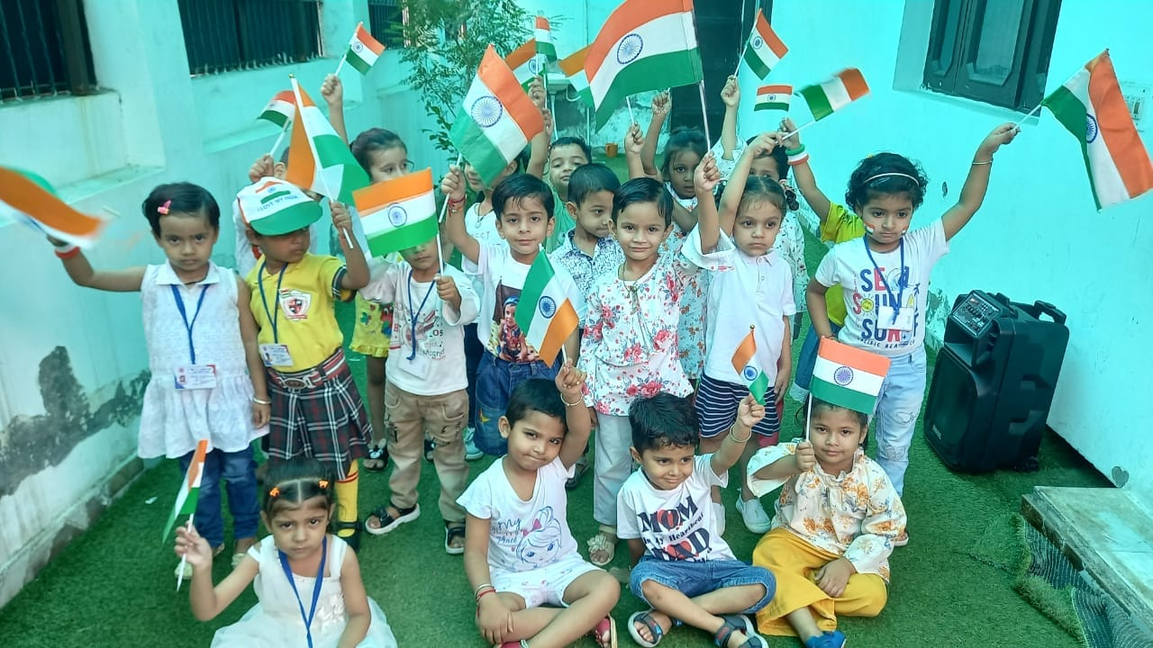
The Independence Day of India, which is celebrated religiously throughout the Country on 15 August every year, holds tremendous ground in the list of national days, since it reminds every Indian about the dawn of a new of a new beginning, the beginning.

of an era of deliverance from the clutches of

British colonialism of more than 200 year.

It was on the fateful morning of 15 August 1947 that India was declared independent form British colonialism, and the reins of control were handed over to the leaders of the Country. India's gaining of independence was a tryst with destiny, as the struggle for freedom was a long and tiresome one.
witnessing the sacrifices of many freedom fighters.

REPUBLIC DAY:
Indian became a Republic when the Constitution the Country came into force on 26th January 1950, thereby defining it as a Sovereign Socialist Democratic Republic with a Parliamentary form of Government, through the Preamble. The Indian Constitution, which was adopted by the Constituent Assembly after considerable discussions, represented the framework of the Government of the Country. Hence forth, 26th January has been recognized and celebrated as India's Republic Day with great ardor, and is decreed a national holiday.
GANDHI JAYANTI:
The 2nd of October is dedicated to Mohandas Karamchand Gandhi when the whole nation celebrates Bapu's birthday.
UTKAL DIVAS:
Utkal Divas or Odisha Divas is celebrated each year in the month of April 1". It is because on this day in 1936, Odisha became a separate province. In the ancient times, Orissa was the centre of Kalinga Kingdom, although it was temporarily conquered (250 B.C) by King Asoka and Maurya held it for nearly a century.
CONCLUSION:
Needless to say - over the years, with all its consistent efforts - the organization does have come across some milestones in its march towards perfection in perception even though it has yet to attain its goal i.e its dream for the cause of the deprived, women in difficult circumstances, disadvantaged and backward people.
Despite fund constraints- effort to take up and cope up new activities has never stopped as our dream never ends. As yet, we work with the belief" God Overhead and Heart Within".
MEGHNA CHARITABLE TRUST is still concerned over its MISSION & VISON that is interwoven with its relevant and consequent need for deciding upon its approach towards the poor and marginalized –
especially the poor, disadvantaged including the urban poor. It hopefully waits for all sorts of possible cooperation from different corners of society to see its VISION comes true.

With Hearties Welcome!

Bhubaneswar Bikram Kumar Pradhan
Managing Trustee

